
Toxic waste in the St. Lawrence River.

Toxic waste has contributed to the problems in the St. Lawrence River in many ways.

There are always going to be problems in water systems such as rivers, however, the attention that the St. Lawrence River system is turning people of the Quebec government’s heads. It seems there are many serious issues with the health of the animal, plant, and even human life living around that area.

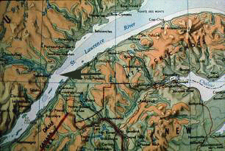
Health of Beluga
Figure 1.0: St Lawrence Estuary, Quebec, Eastern Canada. The habitat of beluga whales is approximately centered on Tadoussac (arrow). The Labrador current flows southwestward in deep water (300 m) in the Laurentien channel in the middle of the Estuary (pale area). This current ends up abruptly at the level of Tadoussac village (arrow) where it surfaces.

Figure 1.1:
St. Lawrence Shoreline
http://www.ntic.qc.ca/~stockrep/beluga_an.html

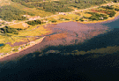

Affects on fishing and farming

Other problems occurring are that many native and non- native people have been loosing their jobs due to the negative impact of the St. Lawrence water pollution on fishing and even on farming, possibly because it was unsafe to irrigate directly from the river.

http://www.tuscaroras.com/graydeer/pages/Toxicturtle4.htm

Affects on Government

Because governments have to spend so many of their resources on political activities (national, state, provincial) fewer resources are available to take action in cleaning the river. Pollution from one country effects the other in negative ways and governments have to use a lot of resources to analyze and correct these problems.

http://www.ijc.org/comm/6bre.html

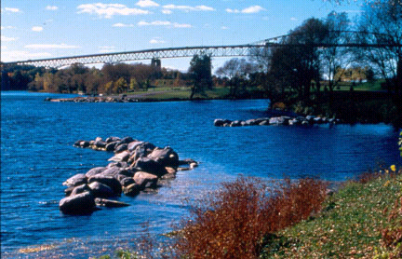
In conclusion, there have been many concerns involving the St. Lawrence river. Many problems in the St. Lawrence have been contributed to by toxic waste issues that have had a negative impact on many people. If you stepped back and took a good look at the issues mentioned in this report, keeping in mind that only very few were actually mentioned, you can hopefully see how we, as keepers of the earth, we are virtually destroying the very land that takes care of us so well day after day. In mentioning this it is in the best interests of the entire world that we learn to take responsibility for our actions and work together at making our world, and our home, a better, safer, more beautiful place to live for all of us.
Figure 1.2: (St-Lawrence River at Seaway International Bridge in Cornwall, ON)

